Acoustic and Noise Research Group
Auralization of Good and Bad Acoustic Spaces
MECH Co-op Work Term Report
Yihan Yanglou
Fall 2013

CATT-Acoustics Models and auralization audio demo files for three real environments, the CIRS Acoustic and Noise Research Lab, the CIRS Building Simulation Software Lab and the UBC Point Grill Restaurant, and two simple acoustical virtual environments, were created in this project. The effects of a silencer, sound masking system and baffles were investigated for auralization. Differences in reverberation times in a large room, and decibel decrease sound files, were auralized.

Contents
Introduction 1
Environments 1
Case 1: CIRS 2160 2
Case 2: BSS Lab 2
Case 3: The Point Grill Restaurant 2
Case 4: Reverberation Time and Decibel Demos 2
Method 2
Recordings 2
Modelling and Auralization 3
Case 1 3
Case 2 5
Case 3 5
Case 4 6
Convolution 7
Calibration 8
Results 8
Case 1 8
Case 2 9
Case 3 10
Case 4 11
Conclusion 11
References 12
Appendix A: Walker Module a
Set-up a
In CATT-Acoustic Software b
HRTF and Headphone EQ b
Walker Module b
Appendix B: File Descriptions d
Folder: Reverberation Differences d
Folder: Point Grill d
Folder: Decibel Decrease e
Folder: BSS Labs e
Folder: Acoustic and Noise Control Office f

List of Figures
Figure 1: Auralization Process (Kleiner) 1
Figure 2: Sketch-Up Model of Silencer 3
Figure 3: Acoustic Labs CATT Model without Silencer 4
Figure 4: Acoustic Labs CATT Model with Silencer 4
Figure 5: BSS Lab CATT Model 5
Figure 6: Point Grill AutoCAD Model 5
Figure 7: Reverberation Model 7
Figure 8: Decibel Decrease Model 7
Figure 9: Acoustic Lab Source and Receiver Positions 8
Figure 10: Acoustic Lab Walker Receiver Positions 9
Figure 11: BSS Lab Source and Receiver Positions 9
Figure 12: BSS Lab Sound Masking Source Positions and Receiver 3 Position 10
Figure 13: Point Grill Source and Receiver Positions 10
Figure 14: Untreated Point Grill CATT Model 11
Figure 15: Treated (Baffles) Point Grill CATT Model 11

List of Tables
Table 1: % Sound Absorption for Materials of Silencer 3
Table 2: Transmission Co-efficient for Glass 3
Table 3: % Sound Absorption of Materials for the Point Grill 6

Introduction
Auralization is the process of making audible the sound field of a source at a given point in a modeled space, in a way as to simulate the binaural listening experience (Kleiner – see Figure 1). There are multiple kinds of auralization, but the method used in this project is the fully computed auralization that predicts the binaural room impulse response (BRIR). Using CATT-Acoustics, a prediction model of the room, with wall properties such as absorption coefficients and coordinates, is input into the ray tracing algorithm to compute a room impulse response (RIR) and the BRIR. Convolution is applied using the RIR and the BRIR to filter the audio signal. Both the calculation and signal processing are included in CATT-Acoustics. CATT uses ray-tracing to model sound waves, and randomised tail-corrected cone-tracing (RTC) for further detail.

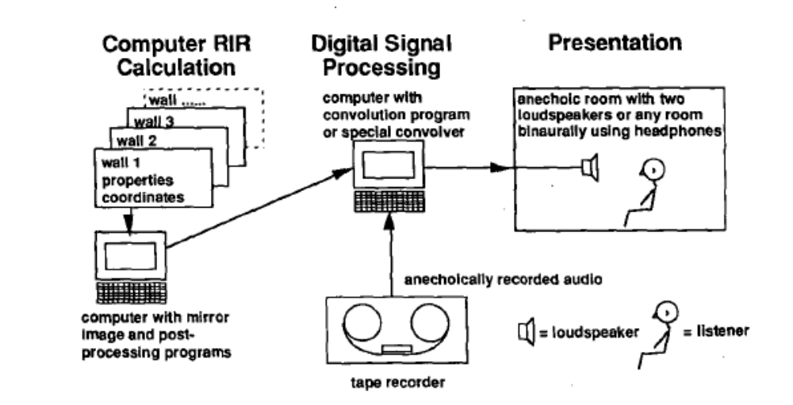
Figure 1: Auralization Process (Kleiner)
The objective of this project was to create sound files of bad and good acoustic environments before and after treatment, respectively. This report describes the process to auralize sound in a modelled environment, from recording an anechoic wav file to convolution in CATT-Acoustics.

Environments
The environments modelled were the CIRS Acoustics and Noise Control Office and Lab, the CIRS Building Simulation Software Lab (BSS) and the Point Grill. Demo audio files of reverberation and decibel reduction were also created.

Case 1: CIRS 2160
The Acoustics and Noise Control Office and Lab (CIRS 2156 and 2160) in the Centre for Interactive Research on Sustainability (CIRS) at UBC has been the target of extensive study of silencers and airflow. Originally, the space contains a small inner office within the lab, which is sectioned off with two partitions. One made from glass. There is a natural ventilation opening at the glass wall, which is otherwise of lightweight glass construction with a solid wooden door. This wall provided inadequate attenuation of sound. A U-shaped silencer was developed and implemented in this opening (Samimi). Three situations were modelled, with the natural ventilation wall as the focus: natural ventilation, silencer, and solid wall. Walker (See Appendix A) files, which allows a listener to walk through a space with continuous auralization, was also created.

Case 2: BSS Lab
The problem of speech privacy in open-plan offices was investigated. The BSS lab has a very low background noise due to natural ventilation and the cubicles use low, chest-height partitions, which causes sound to easily travel across the room. A masking system was auralized for three different situations. Firstly, a speech source was positioned in the lower middle part of the room (See Figure 11: BSS Lab Source and Receiver Positions). Two positions, far and near the source were auralized with and without the masking system. In another situation, two people speak to each other from across the room, and a receiver at another desk is auralized with and without the sound masking system. Walker files for a real-time auralization environment without sound masking were created.

Case 3: The Point Grill Restaurant
The Point Grill has been noted as an environment with high background noise, high reverberation time, and speech intelligibility problems. The number of people at the restaurant during rush hour cause acoustical problems. Baffles and acoustic panels were implemented in the acoustic model to improve the acoustical environment. A large number of sources were simulated in CATT-Acoustics to represent the number of people eating, and a single receiver was analyzed.

Case 4: Reverberation Time and Decibel Demos
Two small audio demonstration projects of different reverberation times (RT) and the difference in sound level in decibel were created. For RT, a 26x26x11m room was created and the absorption coefficients of the walls were increased. This resulted in less reverberation in the room. The second project auralized one sound file at 80dB, 70dB, and 60dB. The room used for these audio samples was a parallelepiped and it had the dimensions 26x50x11m.

Method

Recordings
The sources used anechoic WAV-files recorded on-site and some anechoic files were taken from previous research. New anechoic speech files included two short-distance conversations and one long-distance conversation. In the short-distance recording, two people stood one metre away from each other, with the microphone halfway between them. In the long-distance recording, two people were simultaneously recorded, five metres apart, and facing each other. Microphones were placed half a metre in front of them. The recordings were created using a Soundbook’s SINUS Samurai software, recording signals from ½” microphones. The microphones were calibrated using a calibrator, and the wav files were calibrated using calibration files made by an omni-directional speaker placed at each of the source positions.

Modelling and Auralization

Case 1

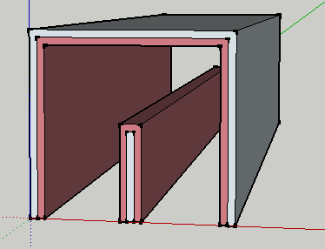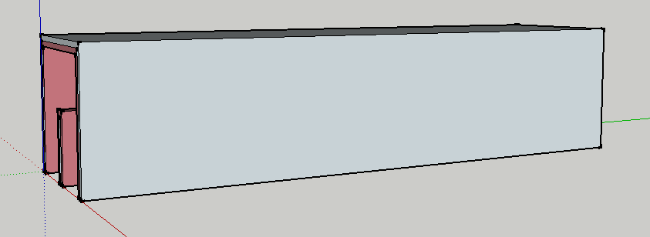
Figure 2: Sketch-Up Model of Silencer
A previous acoustic model, from the 2012 CIRS Acoustics Lab project (Willson), was used; in addition, transmission coefficients for the glass walls were included in the building simulation to model sound transmission through partitions. A silencer was modelled in Sketch-Up and inserted into the CATT-Acoustics model. The materials used for the silencer were 1” porous material for the inner lining and wood for the outer shell.

Table 1: % Sound Absorption for Materials of Silencer
Surface Name in CATT- Acoustics | Frequency Bands |  |  |  |  |  |  |  | Description | Source
Surface Name in CATT- Acoustics | 125 | 250 | 500 | 1000 | 2000 | 4000 | 8000 | 16000 | Description | Source
ABS PLYWOOD | 15 | 20 | 15 | 10 | 10 | 10 | 10 | 10 | Wooden Boards | (Dance)
ABS COTTON | 47 | 65 | 75 | 84 | 83 | 81 | 79 | 77 | Porous material | (Hodgson, “Estimation”)

Table 2: Transmission Co-efficient for Glass
Surface Name in CATT- Acoustics | Frequency Bands |  |  |  |  |  | Description | Source
Surface Name in CATT- Acoustics | 125 | 250 | 500 | 1000 | 2000 | 4000 | Description | Source
ABS PLYWOOD | 0.3 | 0.1 | 0.01 | 0.005 | 0.0015 | 0.0007 | Wooden Boards | (Long)
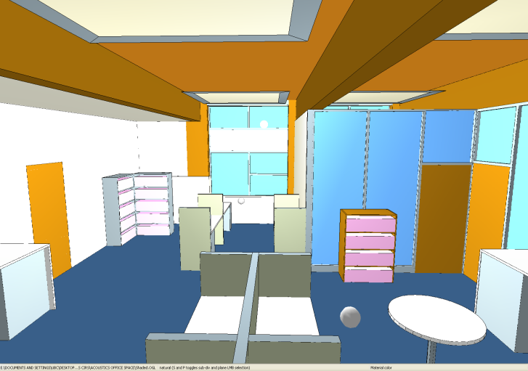
Natural-ventilation opening for insertion of silencer
Figure 3: Acoustic Labs CATT Model without Silencer

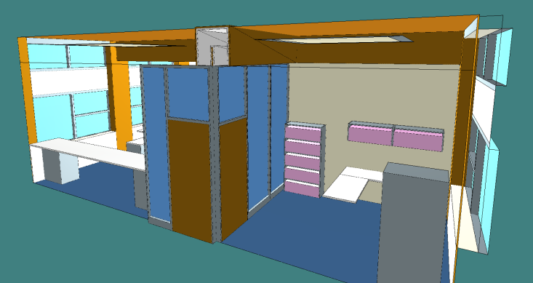
Inserted silencer (Alternate View)
Figure 4: Acoustic Labs CATT Model with Silencer

Different source and receiver positions were used in previous studies. 70000 rays and a truncation time of 10000ms were set in prediction mode (Willson), and auralized accordingly. Walker files of the natural ventilation environment were also created. A separate receiver file was used to create the large number of receiver points needed to create the walker module (See Appendix A).

Case 2
A model from a previous Mech 543 project (Lei) was also used for the BSS lab.
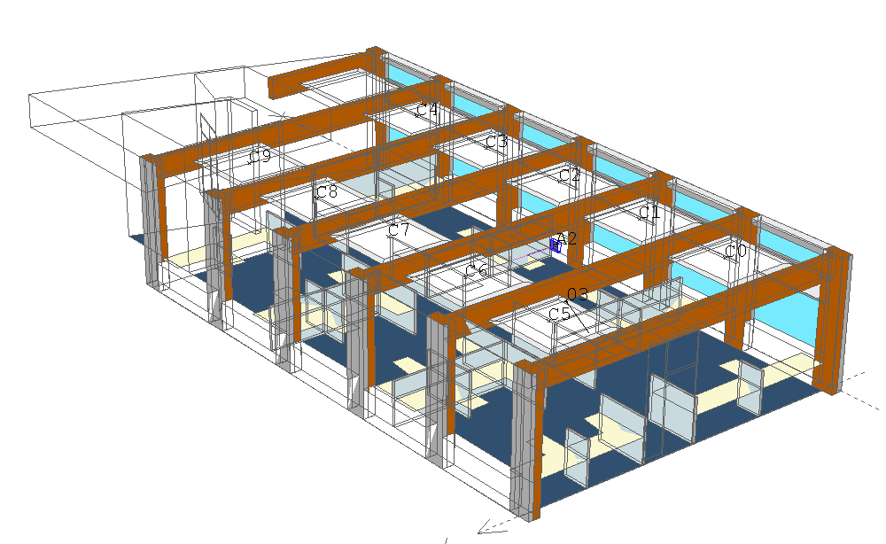
Figure 5: BSS Lab CATT Model
50000 rays and a truncation time of 10000ms were used. Source addition was applied to the auralization of the long-distance sources, as well as the treatment cases of sound masking auralization between the steps of prediction and post-processing.

Case 3
The model of the Point Grill was created in AutoCAD based on architectural CAD file, which are attached in the report, and on physical measurements. Material details were found using the architectural files used in initial construction (The Point Grill UBC Project #C64960).

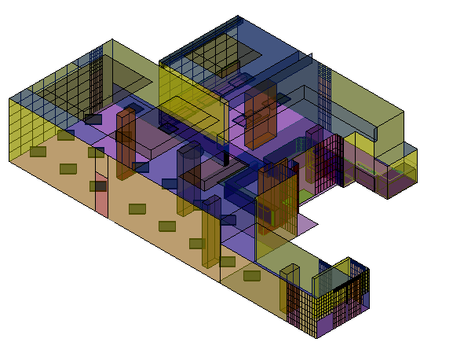
Figure 6: Point Grill AutoCAD Model

Table 3: % Sound Absorption of Materials for the Point Grill
Surface | Frequency Bands |  |  |  |  |  |  | Description | Source
Surface | 125 | 250 |  | 500 | 1000 | 2000 | 4000 | Description | Source
WALL-PANELING | 3 | 15 | 10 |  | 5 | 4 | 5 | Drywall panelling | (Dance)
WALL-STONE | 2 | 2 | 3 |  | 4 | 4 | 5 | Small stones on wall face | (Hodgson, “Mech 405/543”)
WALL-GLASS | 18 | 6 | 4 |  | 3 | 2 | 2 | Glass with frames | (Long 259)
WALL-FABRIC | 3 | 4 | 11 |  | 17 | 24 | 35 | Light fabric over wall | (Hodgson, “Mech 405/543”)
ROOF-HARDWOOD | 31 | 33 | 14 |  | 10 | 10 | 14 | Wood panelling | (Dance)
OPEN_SPACE_WALL | 99 | 99 | 99 |  | 99 | 99 | 99 | Coupling opening, assumed completely absorptive | N/A
SEAT-LEATHER | 44 | 54 | 60 |  | 62 | 58 | 50 | Seats | (Long 259)
WALL-TILE | 2 | 3 | 3 |  | 3 | 3 | 3 | Small reflective tiles on walls | (Hodgson, “Mech 405/543”)
FLOOR-TILE | 2 | 3 | 3 |  | 3 | 3 | 3 | Marble (reflective) tiles | (Hodgson, “Mech 405/543”)
TABLE-PLYWOOD | 6 | 7 | 9 |  | 9 | 8 | 7 | Furniture | (Hodgson, “Estimation”)
DOOR-WOOD | 18 | 14 | 9 |  | 6 | 6 | 5 | Doors, Hardwood | (Long 259)
FLOOR-CARPET | 14 | 19 | 21 |  | 29 | 34 | 38 | Thin carpet | (Hodgson, “Estimation”)
ROOF-PANELING | 12 | 9 | 9 |  | 9 | 8 | 9 | Roof, panelling | (Dance)

The model was imported into CATT-Acoustics using Dxf2Geo. The aural simulation had only 10000 rays and a truncation time of 1000ms due to time limits. The model was verified using 20000 rays and 10000ms truncation. Actual reverberation time measurements and background noise measurements with and without people were recorded. The background noise measurements were input into the prediction background noise option.

Case 4
Figure 7: Reverberation Model was used to create reverberation files. It has dimensions of 2.6m by 2.6m by 11.8m. To change the reverberation time, absorption coefficients of 0.75, 0.5, 0.25, and 0.15 for all frequency bands were applied to create RTs of 0.5s, 1s, 2s, and 3s, respectively. The distance between the source and the receiver, 15m, did not change. 5000 rays and a truncation time of 5000ms were used.
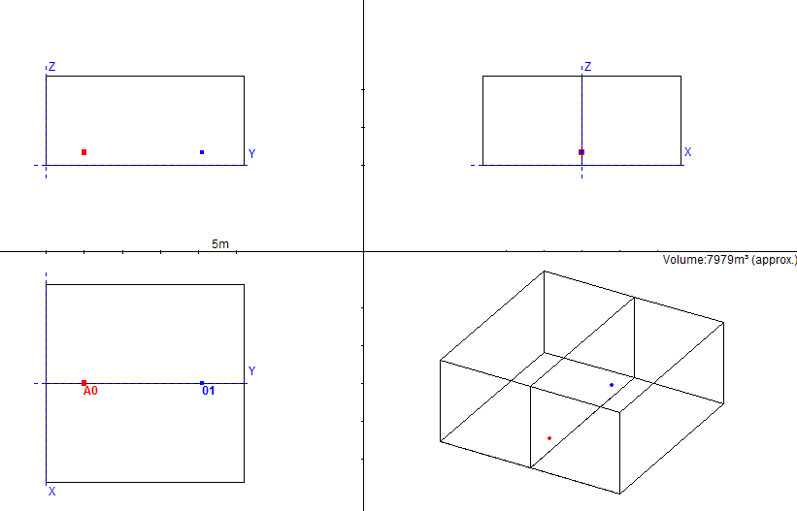
Figure 7: Reverberation Model
In Figure 8: Decibel Decrease Model, the receivers were positioned by doubling of distance away from the source, starting at 2m from the source until 17m (R1, R2, and R3). Spherical divergence theory was used. Even though the source’s sound pressure level of the source can be increased and decreased, CATT acoustics only allows calibration (See Calibration section below) when the receivers have the same source. When the source’s sound pressure levels are changed, the source is considered dissimilar and there is no calibration. The audio files sound the same because the computer maximizes the amplitude for optimum listening experience. This is why the doubling of distance, to move various sources backwards and reduce levels, was used.
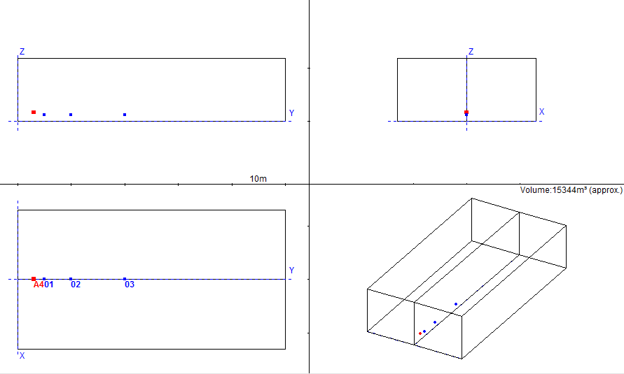
Figure 8: Decibel Decrease Model

Convolution
All files were convolved using the KEMAR artificial head filter. This filter is a diffuse-field equalized set where the “measured at ear-drum” rather than “measured at blocked ear canal” effect is removed. This allows the auralized files to be listened to without a special headphone filter, as long as the headphone is diffuse-field equalized, which is common, although not standardized (Dalenbäck). The files can be used as demonstration auralization files, and users can experience sound situations without having to buy a specific type of headphones.

Calibration
When played, wav files are automatically amplified to increase sound quality. However, this distorts listening files for comparison of different cases. Calibration is a utility option in CATT-Acoustics post-processing module that scales all wav files in the same folder when one of the sound files is selected. All wav files were calibrated together to allow for aural comparison.

Results
Wav files are included with this report. Details of the situations auralized are described below. A list of the files included with this report can be found in Appendix B.

Case 1
The Acoustic and Noise Research lab had one source (B0) and two receiver positions (01, 02). The recording was a made with the help of Murray Hodgson. The Walker module was created with a separate source file that had a large number of receiver points, as shown below. The same source was used, but the anechoic wav file that is being convolved can be changed in the Walker.exe plugin at any point. No further calculations are needed.

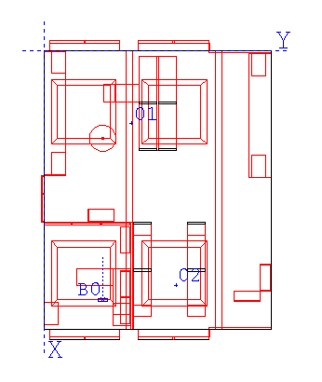
Figure 9: Acoustic Lab Source and Receiver Positions
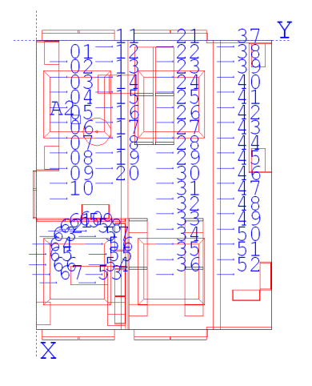
Figure 10: Acoustic Lab Walker Receiver Positions

Case 2
Two different source positions and three different receiver positions were used. The two sources included:
- Long-distance conversation, two sources (A0, A1)
- Short-distance conversation, one source (A2)
The three receiver positions were randomly chosen, with one position near to source A2 to explore the effects of masking systems at close quarters. However, it was discovered that despite the shorter distance, the masking system had the same effect on the auralization; the conversation was not heard.
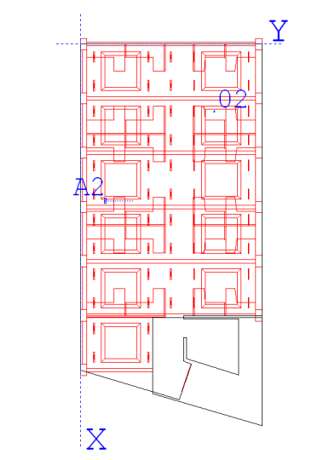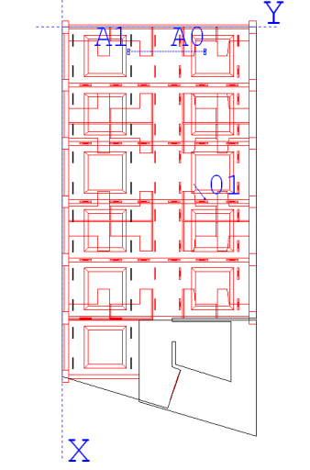
Figure 11: BSS Lab Source and Receiver Positions
The positions of the acoustic treatment, the masking system, and the position of the third reciever (03) are shown in Figure 12.
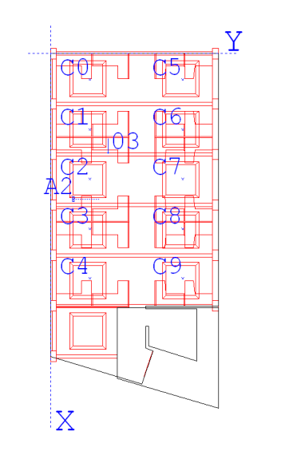
Figure 12: BSS Lab Sound Masking Source Positions and Receiver 3 Position

Case 3
Due to the complexity of the Point Grill, only one receiver was auralized. 80 sources were used; one source (A1) was auralized with an intelligible speech sound file and the other sources were auralized with a noise sound file. The sources were positioned around tables as shown in the diagram. The receiver (01) faces A1.
Source with its respective receiver
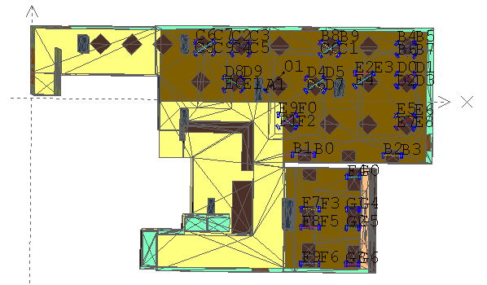
Figure 13: Point Grill Source and Receiver Positions
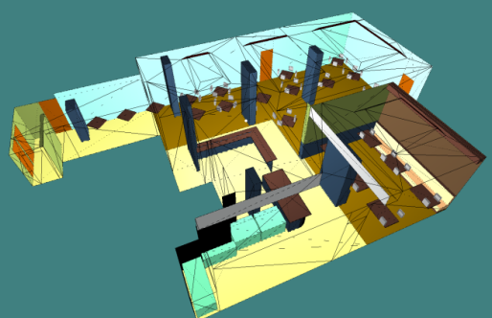
Two versions, one with baffles as acoustic treatment, and one without baffles (untreated), are included with this report. The baffles reduced the reverberation time to 0.5s from the original 1s.
Figure 14: Untreated Point Grill CATT Model

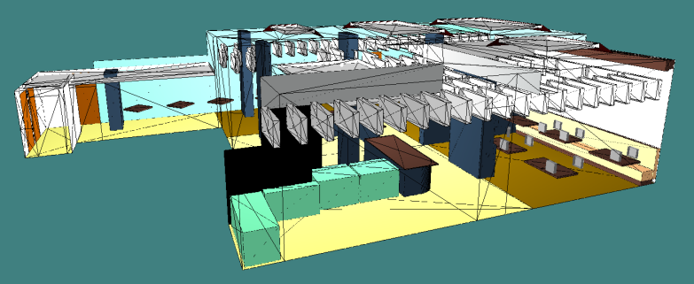
Figure 15: Treated (Baffles) Point Grill CATT Model

Case 4
See the wav files attached.

Conclusion
Auralization using ray-tracing is a method that allows a listener to hear the effect of the treatment of a bad acoustical environment. The process takes a large number of steps, from anechoic recording to modeling and, finally, prediction and convolution. Due to the Sabine/Eyring theory used, the reverberation times for the models are approximate and potentially over-estimated. There are no wave effects and the results may not be accurate due to the approximation of absorption coefficients. However, for demo audio files, CATT-Acoustics is able to demonstrate the differences in treated and untreated sound environments. It is a reasonable program for creating such kinds of files for the general public. More work and detail would need to be implemented in the Point Grill model for actual research purposes.

References

Dalenbäck, Bengt-Inge. "CATT-Acoustic V8/v9 Users' Page." CATT Users Display. 11 Dec. 2013. PDF.
Dance, S. and B.Shield, “Absorption Coefficients of Common Construction Materials for Use in Computer Modeling of Enclosed Spaces,” Journal of Building Acoustics, Vol.7, No.3, 2000.
Hodgson, M. & K. Scherebnyj, “Estimation of the Absorption Coefficients of the Surfaces of Classrooms,” Applied Acoustics, Vol. 67, No. 9, Pp. 936-‐944, 2006.
Hodgson, Murray, “Mech405/543 Class Notes”
Isherwood, Julian. "Male Speech." Rec. Oct. 1989. Music for Archimedes. Various. Bang&Oufsen, 1991. CD.
Lei, Yizhong. Prediction of the Effect of a Sound-Masking Systen in CIRS including the Lombard Effect. Rep. Vancouver: Acoustic and Noise Research Group, 2012. Report.
Long, Marshall. Architectural Acoustics. Amsterdam: Elsevier/Academic, 2006. Print.
The Point Grill UBC Project #C64960. Vancouver: Denis Turco Architect Inc., 23 July 2009. PDF.
Samimi, Mina. Optimal Silencer Design for an Interior Natural Ventilation Opening: Combined-Performance Characterization. Rep. Vancouver: Noise and Acoustic Research Group, 2013. Print.
Willson, Nathan. Auralization of the CIRS Acoustic Office Space. Rep. Vancouver: Acoustic and Noise Research Group, 2012. Report.

Appendix A: Walker Module
In CATT-Acoustics, the walkthrough simulation is very similar to static auralization with a few exceptions. The Walker module is a plugin that is not a part of the main CATT-Acoustics software. It is real-time auralization through interpolation of a large number of receiver points based on the x, y, and z positions in the simulation. It outputs B-format input responses that are read using Virtual Studio Technology (VST) Host and the Virtual Audio Cable software. B-format audio files are stored in four mono wav files labeled (W, X, Y Z). VST Host is a software interface that integrates software audio and effect plugins and audio editors and hard-disk recording systems. Included is a VST plugin that allows reading of this audio file, WigAmbiDec_1o_GUI.dll. The Virtual Audio Cable feeds the B-format output of the Walker into the VST Host, and converts it using the WigAmbi plugin, and sends it out as output for headphones.
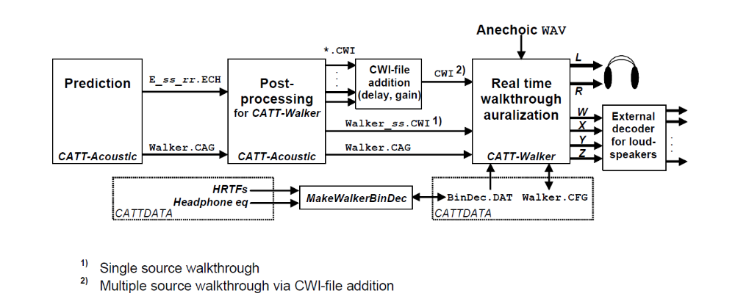

Set-up
- Open VST Host
- If WigAmbi does not show up on VST Host when the program starts up, simply drag and drop WigAmbi into the software.
- Virtual Audio Cable transfers the audio streams from one application to the second application, and then output headphones. It should be set in the input port inside VST Host, which can be accessed in Wave Device Setting dialog in the Devices menu.
- Do not close VST Host. It should be open for the Walker module to function properly.
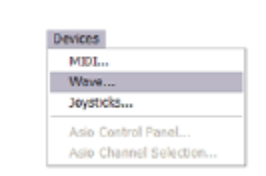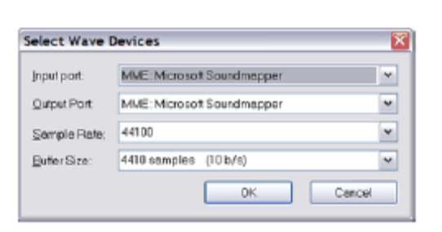

In CATT-Acoustic Software
There are two files that are needed for the Walker module, the .CAG (CATT-Acoustics Geometry File), which has information about geometry, sources, and receivers used for the prediction, and .CWI, which contains the impulse response calculations. A separate receiver file to be used in the prediction module is suggested, but, alternatively, receiver points can also be toggled on and off.
In the Prediction Module
- Create a .REC file with a large number of receiver points. The more the impulse responses are expected to change while the listen position or head direction moves, the more density is required. Some functions such as recwalk(), recloop() and recloop2() can be helpful to create large arrays or receiver points. The head direction of these receivers does not matter.
- Check Save data for post-processing in Full Detailed Calculation. A .CAG file will created.
- Run Prediction
In Post-Processing Module
- Click on General Settings
- Select B-Format file for the receiver file
- Select OK
- Check-mark the box next to Create CWI-file for CATT-Walker
- Select Save and Run

HRTF and Headphone EQ
If a new HRTF and/or Headphone EQ is used, a separate program called MakeWalkerBinDec.EXE needs to be called so that the preferred filters will be saved as the file BinDec.DAT for CATT-Walker. It only needs to be run every time the headphone EQ or HRTF is changed.

Walker Module
- Open up Walker.EXE and press Config
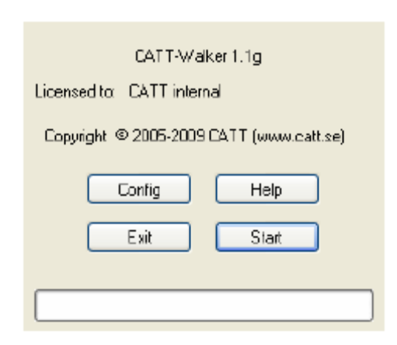
- This dialog will show up:
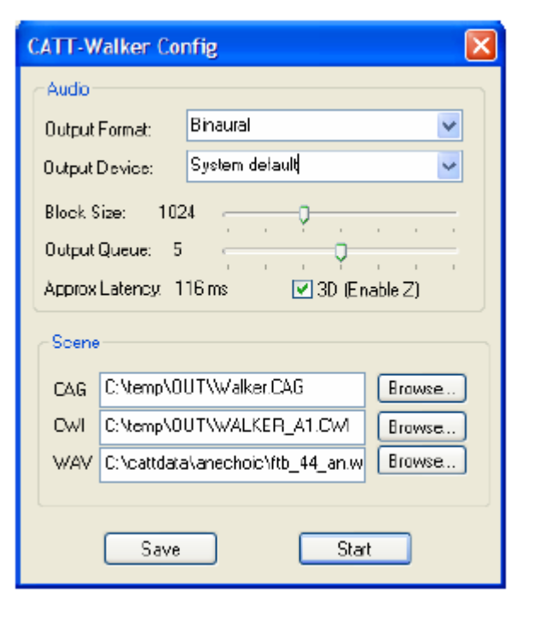
- Select the .CAG and .CWI files previously created.
- Select the anechoic wav file
- Press start.
- Use the arrow keys to move around and the mouse to change the head direction of the Walker.

Appendix B: File Descriptions

Folder: Reverberation Differences
File | Description
point5s.txt | Quantitative information for auralization
point5s.wav | Reverberation time of 0.5 second
1s.txt | Quantitative information for auralization
1s.wav | Reverberation time of 1 second
2s.txt | Quantitative information for auralization
2s.wav | Reverberation time of 2 second
3s.txt | Quantitative information for auralization
3s.wav | Reverberation time of 3 second

Folder: Point Grill
File | Description
Point Grill Untreated.wav | Quantitative information for auralization
Point Grill with Baffles.wav | Reverberation time of 0.5 second
Point Grill AutoCad Model | Model of Point Grill for AutoCad. Meshed.
Point Grill CATT Files | These files can be used to recreate the point grill in CATT. The model can also be exported into AutoCad from CATT. A new Prediction file should be created.
Point Grill Architecutral File.zip | CAD Files from Loriann McGowen. It has material details and measurements of the building.

Folder: Decibel Decrease
File | Description
60DB.wav | File amplitude will be determined by headphone output gain. If unchanged, the three files will allow the listener to hear increases in 10dB between each of the files
70DB.wav
80DB.wav

Folder: BSS Labs
File | Description | Source | Receiver
Masking A0,A1-R01.WAV | Long-distance speech sources with one receiver position, with sound masking system sound addition | A0-A1 | R01
Masking A2-R02.WAV | Short-distance speech source, receiver position far from source, with sound masking system sound addition | A2 | R02
Masking A2-R03.WAV | Short-distance speech source, receiver position near source, with sound masking system sound addition | A2 | R03
No Masking A0,A1-R01.WAV | Long-distance speech sources with one receiver position | A0-A1 | R01
No Masking A2-R02.WAV | Short-distance speech source, receiver position far from source | A2 | R02
No Masking A2-R03.WAV | Short-distance speech source, receiver position near source | A2 | R03
BSS Labs Walker.CAG | Untreated BSS Lab environment real-time simulation using walker.exe | N/A | N/A
BSS Labs Walker.CWI |  | N/A | N/A

Folder: Acoustic and Noise Control Office

File | Description | Source | Receiver
OPENSPACE_R01.WAV | Natural Ventilation | B0 | R01
SILENCER_R01.WAV | Silencer above partition | B0 | R01
SOLIDWALL_R01.WAV | Solid wall above partition | B0 | R01
OPENSPACE_R02.WAV | Natural Ventilation | B0 | R02
SILENCER_R02.WAV | Silencer above partition | B0 | R02
SOLIDWALL_R02.WAV | Solid wall above partition | B0 | R02

File | Description
Acoustic Office Walker.CAG | Used to make natural ventilation real-time walker simulation.
Acoustic Office Walker.CWI
Silencer Walker.CAG | CIRS Acoustics lab with silencer, real-time walker simulation
Silencer Walker.CAG
Silencer.skp | Sketch-Up file of silencer. The file can be imported into CATT using SU2CATT plugin. A demo can be downloaded online.

