--- Research Report ---

The effects of vegetation associated with highway noise barriers on residential soundscapes

Maureen Connelly, MAIBC PhD, British Columbia Institute of Technology Centre of Architectural Ecology, maureen_connelly@bcit.ca

Yihan Yanglou, University of British Columbia, Mechanical Engineering

--- December 2013 ---

Executive Summary

This project focused on the investigation of the potential of vegetation associated with highway noise barriers to affect the soundscape of the noise-protected areas behind the barrier. There are no existing fully vegetated Criblock™ barriers designed $Criblock^{TM}$within a context suitable for the research focus; thus, alternative highway barriers with associated vegetation are explored. Seven different residential properties along one street and located behind a single length of highway noise barrier were selected. Each residential backyard is quantified by a measure of vegetation and near infinite-impedance boundaries estimated with 3D-AutoCAD modelling. Three-minute samples of each soundscape were recorded using a ½” microphone connected to a Sinus Soundbook. From the recordings, 49 acoustical and soundscape parameters were analyzed statistically.
Using the acoustical and soundscape parameters, different structural forms of vegetation associated with the highway traffic barriers were defined by clustering analysis. The clustering showed three distinctly different soundscapes behind the highway noise barrier. Soundscape A, with the largest number of data sets, was analyzed further. Select acoustical and soundscape parameters were plotted against the specific landscape parameter. Correlations were found in the scatter plots between the specific landscape parameter and the A-weighted sound level (L_{Aeq}), and the temporal sound level variance descriptor (TSLV) which describes the modulation of pressure amplitude over time. The negative correlation between L_{Aeq} and the landscape parameter (R² = 0.8) models an increase in backyard/barrier vegetation as providing a perceivable reduction in A-weighted sound-pressure levels. Most anthrophony sounds occur predominantly below 2 kHz and biological sounds occur from 2.5 to 9 kHz. Both flat and A-weighted ratios of biophony/ anthrophony frequency band were investigated. Although ratios are distinct between soundscapes A, B and C, the ratios are constant throughout the properties in Soundscape A.
Using cluster analysis, different soundscapes relative to the amount of vegetation and vegetation structure were defined. Further acoustical and soundscape parameters were correlated to a specific landscape parameter. This preliminary study indicates that with an increased in data collection (the L_{Aeq} the TSLV and specific landscape parameter), a model to determine the effect of the vegetation associated with Criblock™ barriers on the soundscape is viable.

Table of Contents

Executive Summary 2
List of Figures 4
List of Tables 5
Introduction 6
Literature Review 6
Problem Statement 8
Method 8
Sites 8
Data Collection 10
Statistical Analysis 10
Clustering 10
Results 12
Conclusion 17
References 18
Appendix 19
Appendix A : Site Aerial Views and AutoCAD Models 19

List of Figures

Figure 1: Highway Barriers and Associated Vegetation 9
Figure 2: Clustering of 49 Parameters 12
Figure 3: A-weighted sound pressure level and specific landscape descriptor 14
Figure 4: A-weighted biophony/anthrophony ratio and amount of 2D absorptive material 15
Figure 5: Linear biophony/anthrophony ratio and The specific landscape perimeter 15
Figure 6: Focus on Soundscape A - A-weighted sound pressure and specific landscape descriptor 16
Figure 7: Focus on Soundscape A – TSLV and specific landscape descriptor 16
Figure 8: AutoCAD Model - 5122 59A St 19
Figure 9: AutoCAD Model - 5098 59A St 19
Figure 10: AutoCAD Model - 5076 59A St 20
Figure 11 AutoCAD Model - 5052 59A St 20
Figure 13: AutoCAD Model - 5040 59A St 21
Figure 14: AutoCAD Model - 5018 59A St 21
Figure 15: AutoCAD Model - End of 51st 22

List of Tables

Table 1: Geophony, Biophony and Anthrophony 7
Table 2: Acoustic and Soundscape Parameters 12
Table 3: Data 14

Introduction

This project focuses on the investigation of the potential of vegetation associated with highway noise barriers to affect the soundscape of the noise-protected areas behind the barrier. As there are no fully vegetated barriers as designed by $Criblock^{TM}$, the industry partner of this investigation, within context suitable for the research focus; alternative highway barriers with associated vegetation are explored.
There is a potential in vegetation to change the soundscape of a highway barrier. Studies have shown foliage effects sound through scattering and absorption, depending on the type of foliage in the space. Above 1000Hz, broad-leafed trees higher than highway barriers scatter sound into the shadow zone of the barrier, increasing levels by 8dB. Evergreens positioned on the non-traffic side of the barrier decrease sound from 2-5dB, depending on its density, and Ivy vines around a barrier absorb up to 5dB of frequency (Daltrop). However, little study has been done on the effects of vegetation near a highway barrier on the soundscape.
A current method of soundscape classification through acoustic parameters was applied to the selected sites. 49 acoustical parameters describing amplitude, spectral variability and frequency are used to classify different types of soundscapes through hierarchical clustering. Further analysis is completed by investigating correlations between the cluster structure, select acoustical and soundscape parameters and a specific landscape perimeter defined by this investigation.

Literature Review

The term soundscape was first coined by the Canadian composer and environmentalist, R. Murray Schafer and the definition has changed and varied from researcher to researcher. Schafer states the soundscape is a combination of sounds in an ecological relationship to life and society. Various different methods have been explored to classify and categorize soundscapes. Bernard Krause defined the soundscape in terms of three main sound sources, geophony, biophony and anthrophony.

Table 1: Geophony, Biophony and Anthrophony

Element | Definition | Example
Geophony | Sounds generated by non-biological, natural sounds | Wind rustling the trees, water sounds from a stream
Biophony | Non-human, non-domestic biological sounds | Birds chirping
Anthrophony | Sounds generated by humans | Car traffic, human talking, electrical generators

Most anthrophony sounds occurs dominantly below 2 kHz and biological sounds occur from 2.5 kHz to 9 kHz. (Joo). It has been found in previous research that acoustic properties of urban systems are correlated with landscape attributes. Along an urban-rural gradient, most anthrophony frequencies fall under 1-2 kHz range and biophony in the 3-4 kHz range (Joo).
A categorization method of particular interest uses psychoacoustic parameters Loudness, Roughness, and Sharpness (Rychtarikova). The acoustic parameters, A-weighted sound pressure level, temporal sound level variance descriptor (TSLV) and the spectrum gravity center, attempt to describe sound in similar ways (Torija). The psychoacoustic parameter, sharpness, is weighted on a sharpness curve to compensate for the human hearing aspect of sound (Cox) is a ratio of frequencies similar to the ratio of biophony to anthrophony The 49 acoustical parameters used for clustering are defined in methods section. The A-weighted sound pressure level, TSLV and the spectrum gravity center are further described as follows:
- A-weighted equivalent sound pressure describes the amplitude of sound as heard from a human receiver. A-weighting balances low frequency components, particularly in broadband sounds, to weight sound pressure based on the anatomy of the human ear.
- TSLV describes how the rapid amplitude modulation over time and it can be used to measure annoyance. The variance of sound pressure level can be heard in an impulse or a sinusoidal wave, which as a steady amplitude modulation. The parameter finds the standard deviation of octave bands of the sound pressure level and then averages the deviation (Torija).
$$TSLV=σ_{L_{Aeq}}σ_{L_{eq}}$$
TSLV is weighted by multiplying the standard deviation of the A-weighted sound pressure level with the energy equivalent sound pressure level. It does not take into account the masking depth of the ear, a perceived smaller drop in sound because of the rapid modulation of sound.
- The spectrum gravity center is used to characterize the spectral composition of the soundscape (Raimbault). The sound pressure level in each one third octave band was converted into energy and multiplied by frequency. It is then divided by the total sound energy.
$$G=\frac{\sum_{i}{{10}^{\frac{L_{i}}{10}}xf_{i} }}{\sum_{i}{{10}^{\frac{L_{i}}{10}}}}$$

Problem Statement

The project investigates correlation between the amounts of vegetation and the soundscape in a specific area behind a highway noise. What effect does the amount of vegetation associated with the highway barrier have on soundscape?

Method

Sites
Seven different homes along one street in Ladner, British Columbia were selected because they were located behind a single length of highway noise barrier. The focused areas of study were bounded by the property lines of each residential backyard, and were analyzed because it is the area that the resident lives and experiences the soundscape. Furthermore, it is the area in which they are able to alter the materiality of change the soundscape.
Each residential backyard was quantified by a measure of vegetation and near infinite impedance boundaries estimated with 3D AutoCAD modelling based on pictures in aerial and ground view. A scale from the aerial map was used for accuracy (See Appendix A).

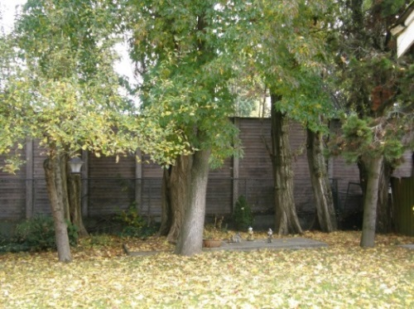
(1)
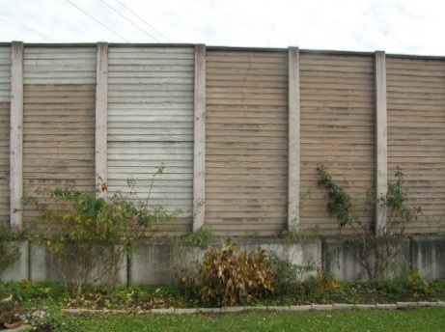
(3)
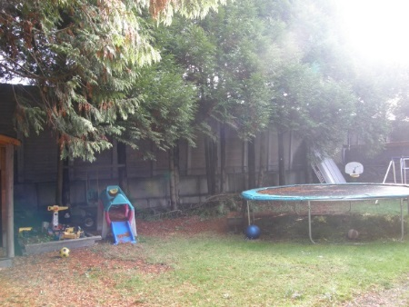
(5)
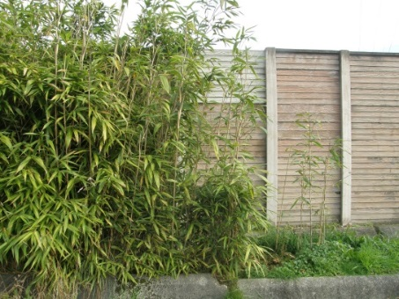
(7)
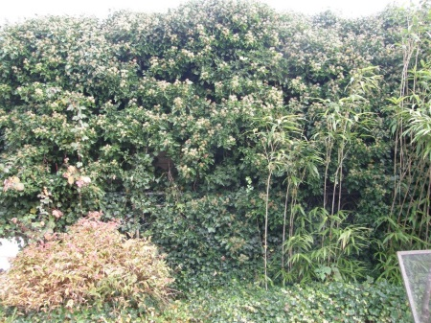
(2)
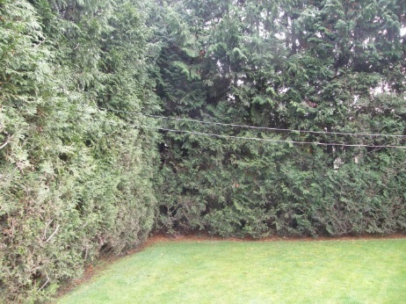
(4)
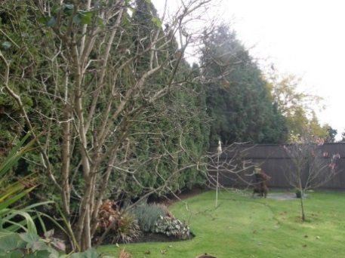
(6)

Figure 1: Highway Barriers and Associated Vegetation
1) 5122 59A St; 2) 5098 59A St;
3) 5076 59A St; 4) 5052 59A St;
5) 5040 59A St; 6) 5018 59A St;
7) End of 51st

Data Collection
Three minute samples of each soundscape were recorded using a ½” microphone connected to a Sinus Soundbook. The microphone were set up behind the barrier with varying due to terrain, with a general distance from the ground of 1.2m and with a measured distance from the barrier of 6m. The test was repeated three times. Samples for each soundscape were first taking consecutively, and starting from the first soundscape recorded, repeated two more times.
In all cases, there was a fairly continuous flow of vehicles, and because of the method of sound sampling, the averaging of three sets of samples at different times in the day helped reduce error from the variability in the sound source. Noise levels were analyzed in third-octave bands from 20-2000Hz.
Using AutoCAD models of the sites, six different landscape parameters to described the amount of landscape vegetation in area and/volume were explored. Five parameters were investigated; 1) a measure of the area of grasses and planting beds in the back yard in square meters, 2) a measure the vertical area of the backyard perimeter in square meters, 3) a measure of the total vertical and non-vertical vegetated surfaces bounding the backyard site, 4) a measure of vegetation in backyard in cubic meters, 5) a measure of vegetation with the ground area as a 0.2 height volume added in cubic meters.

Statistical Analysis

Clustering
Agglomerative hierarchical clustering was completed using Matlab and the Fuzzy Toolbox. Individual clusters are grouped together based on similarity using single linkage, where the clusters with the shortest linkages, or most similar, are combined and Euclidean distance of the parameters:
$$d\left(p,q\right)=d\left(q,p\right)=\sqrt{{\left(q_{1}-p_{1}\right)}^{2}+{\left(q_{2}-p_{2}\right)}^{2}+…+{\left(q_{n}-p_{n}\right)}^{2}}$$
Based on the Euclidean distances, a dendrogram is plotted. The y-axis distances in the graph denote inconsistency between clusters. The larger the distance between the links, the more it suggests natural divisions in the data set (“Hierarchical Clustering”).
49 parameters (“Samurai(TM) Basic Version Manual”) from the Soundbook were analyzed, (described in the Table 2).

Table 2: Acoustic and Soundscape Parameters
Parameter | Description
$$L_{Aeq}$$ | The equivalent continuous A-weighted sound pressure level, which imitates the loudness contour graphs and adjusts sound pressure levels to reflect a person’s hearing in frequency bands.
$$L_{eq}$$ | The un-weighted sound pressure level.
$$L_{AE}$$ | Sound Exposure Level, A-weighted
$$L_{AF1}-L_{AF99}$$ | the percentile level over the sound pressure level at a specific time ($L_{AF1}, L_{AF5}, L_{AF10}, L_{AF50}, L_{AF90}, L_{AF95}, L_{AF99})$
$$L_{AImax}, L_{AImin}$$ | A-weighted maximum and minimum impulse sound pressure levels
$$L_{Apeak}$$ | A-weighted peak sound pressure level
$$L_{20} – L_{2000}$$ | The 1/3 octave sound pressure level, un-weighted, from 20 Hz to 20000Hz
$$σ_{L_{Aeq}}, σ_{L_{eq}}$$ | Standard deviation of A-weighted and un-weighted sound pressure levels over the 3 minute time segment
$$TSLV$$ | Temporal Sound Level Variance Descriptor is the standard deviation of instaneous a-weighted sound pressure levels, "weighted" with linear standard deviation. This weighting stresses fluctuations at the beginning of the sample recording.
$$G$$ | Spectrum Gravity Center (Centroid). The centroid of sound pressure level.
$$CF$$ | Crest Factor. It is the ratio between the maximum sound pressure and average sound pressure (“Relationship between Road and Railway Noise” Torija).
Biophony/Anthrophony Ratio | The ratio of sound pressure level in frequency bands above 2000 Hz over the sound pressure level in frequency bands below 2000 Hz

Results

The clustering showed the sites 5122 59A St (1), 5098 59A St (2) are similar and 5076 (3), 5040 (5), 5018 (6) 59A St and the end of 51 St (7). 5052 59A St (4) is more similar to the latter group. From the cluster graph, it can be assumed that there are three soundscapes:
- Soundscape A that includes (1) and (2)
- Soundscape B, that includes numbers (3), (5)-(7)
- An outlier, (4) was separated into Soundscape C

Geographically, Soundscape B was located at the east end of the street. It had two residential lots and it was characterized by tall cottonwood groves, which caused high frequency scattering above 1000 Hz. Soundscape A had four residential units which were characterised by evergreen hedges. Soundscape C was physically located within Soundscape A’s defined area. Its uniqueness is attributed to the deficiencies in the highway barrier, for example, the section of the barrier had holes up to 6” in size.

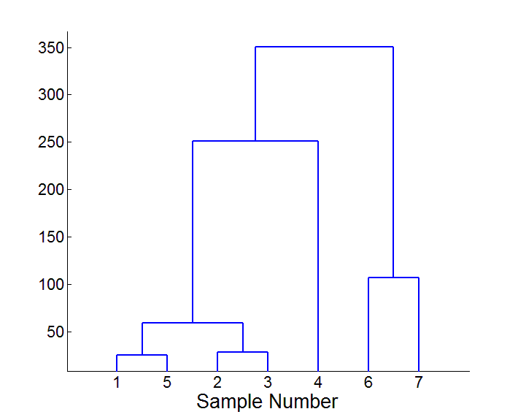
Figure 2: Clustering of 49 Parameters
Table 3: Data
Sample: | 5122 | 5098 | 5076 | 5052 | 5040 | 5018 | 51 end
Sample Number: | 1 | 2 | 3 | 4 | 5 | 6 | 7
Acoustic Properties
L_Aeq | 80 | 78 | 76 | 83 | 80 | 80 | 77
TSLV | 34.7 | 31.0 | 68.5 | 45.9 | 60.7 | 57.0 | 62.6
G | 490 | 529 | 241 | 356 | 261 | 250 | 234
L_Aeq Ratio | 0.046 | 0.046 | 0.012 | 0.031 | 0.017 | 0.020 | 0.015
L_eq Ratio | 0.041 | 0.042 | 0.012 | 0.023 | 0.014 | 0.015 | 0.013
Physical Properties
Specific Landscape Parameter | 633 | 618 | 1417 | 416 | 666 | 446 | 820

The measure of vegetation, called the specific landscape parameter, was selected based on highest correlation with the acoustical parameters the specific landscape parameter in square meters is defined as the total vertical and non-vertical vegetated surfaces bounding the backyard site, following fences, building facades and the highway barrier.
The acoustic and soundscape parameters were plotted against the specific landscape parameter. Strong correlations were found in the scatter plots of $L_{Aeq}$, TSLV, A-weighted and un-weighted biophony/anthrophony ratios against the specific landscape parameter. The parameters were plotted in a semi-log along the x-axis against the five different landscape parameters. It was found that the A-weighted sound pressure level has a correlation to the specific landscape parameter regardless of the soundscape..

Figure 3: A-weighted sound pressure level and specific landscape descriptor

The gravity centroid frequency scatter was graphed, but it displayed no correlation to any of the landscape parameters. The centroid and the biophony/anthrophony ratios are similar because they explore the average frequency of the sound recording over a period of time. Although the biophony/anthrophony ratios are distinct between soundscapes A, B and C, the ratios are constant throughout the properties in Soundscape A. The ratio ranges from 0-1, which means the soundscapes actually have little differentiation between the two. The high correlation is caused by the fact there is little variation in the sound recordings.

Figure 4: A-weighted biophony/anthrophony ratio and amount of 2D absorptive material

Figure 5: Linear biophony/anthrophony ratio and The specific landscape perimeter

Soundscape A, with the largest number of data sets, is analyzed further. Correlations are found in the scatter plots of the specific landscape parameter to the A-weighted sound level ($L_{Aeq}$), and the temporal sound level variance descriptor (TSLV) which describes the modulation of pressure amplitude over time. The negative correlation between $L_{Aeq}$ to the landscape parameter ($R^{2}$ of 0.8) models an increase in backyard/barrier vegetation as providing a perceivable reduction in A-weighted sound pressure levels.

Figure 6: Focus on Soundscape A - A-weighted sound pressure and specific landscape descriptor
Biophony is noted to have more modulation than anthrophony (Krause). This is shown with the TSLV descriptor. It has not yet been determine if the positive correlation between TSLV and the specific landscape parameter describes a perceivable range of amplitude modulation.

Figure 7: Focus on Soundscape A – TSLV and specific landscape descriptor

Conclusion

Using the acoustic and the specific landscape parameters, different structural forms of vegetation associated with the highway traffic barriers were identified by clustering analysis of acoustical and soundscape parameters. The natural data divisions did not change whether 49 or 3 ($L_{Aeq}$, TSLV, and frequency centroid) were used.
There is a strong correlation between the specific landscape parameter and$L_{Aeq. }$ . $L_{Aeq}$had a strong relationship to the landscape parameter across all three soundscapes. In Soundscape A, there were correlations between $L_{Aeq},$TSLV, A-weighted and un-weighted biophony/anthrophony ratios to the landscape parameter with $R^{2}$ between 0.8 and 0.99. However, TSLV may not have a perceivable range of amplitude. There was no correlation to the gravity centroid. The biophony/anthrophony ratios were distinct between soundscapes, but there is very little change in the ratio between residential properties within a single soundscape.
This study indicates that the more vegetation, the quieter the soundscape. An increase sampling of more properties is required to provide statically power, additional seasonality in the data collection and advanced detailed plant physiology parameters are also required. This preliminary study indicates that with an increased in data collection, a model to determine the effect of the vegetation associated with Criblock™ barriers on the soundscape is viable.

References

Cox, Trevor. "Sharpness." University of Salford Manchestor. N.p., n.d. Web. 06 Dec. 2013.
Daltrop, Shira, Murray Hodgson, and Clair Wakefield. "Field Investigation of the Effects of Vegetation on the Performance of Roadside Noise Barriers." Noise Control Engineering Journal 2.March-April (2012): 202-08. Print.
"Hierarchical Clustering." Mathworks. N.p., n.d. Web. 09 Dec. 2013.
Joo, Wooyeong, Stuart H. Gage, and Eric P. Kasten. "Analysis and Interpretation of Variability in Soundscapes along an Urban-rural Gradient." Landscape and Urban Planning 103 (2011): 259-76. Print.
Kleiner, Mendel, Beng-Inge Dalenback, and Pater Svensson. "Auralization - An Overview." Journal of Audio Engineering Society 41.11 (1993): 861-75. Print.
Krause, Bernard L. The Great Animal Orchestra. New York: Little, Brown, 2012. Print.
Raimbault, M., C. Lavandier, and M. Berengier. "AMbient Sound Assessment of Urban Environments: Field Studies in Two French Cities." Applied Acoustics 64 (2003): 1241-256. Web.
Rychtarikova, Monika, and Gerrit Vermeir. "Soundscape Categorization on the Basis of Objective Acoustical Parameters." Applied Acoustics 74 (2013): 240-47. Print.
Samurai(TM) Basic Version Manual. Leipzig, Germany: Sinus Messtechnik GmbH, 6 Jan. 2012. PDF.
Torija, A. J., D. P. Ruiz, B. De Coensel, D. Botteldooren, B. Berglund, and A. Ramos-Ridao. "Relationship between Road and Railway Noise Annoyance and Overall Indoor Sound Exposure." Transport 16 (2011): 15-22. Print.
Torija, Antonio J., Diego P. Ruiz, and A. F. Ramos-Ridao. "Application of a Methodology for Categorizing and Differentiating Urban Soundscapes Using Acoustical Descriptors and Semantic-differential Attributes." Journal of the Acoustical Society of America 2/2 134.1 (2013): 791-802. Print.

Appendix A: Site Aerial Views and AutoCAD Models

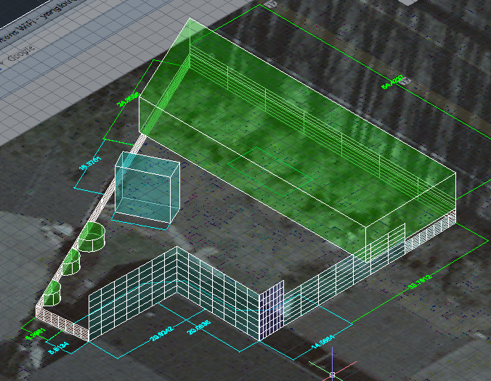
Figure 8: AutoCAD Model - 5122 59A St

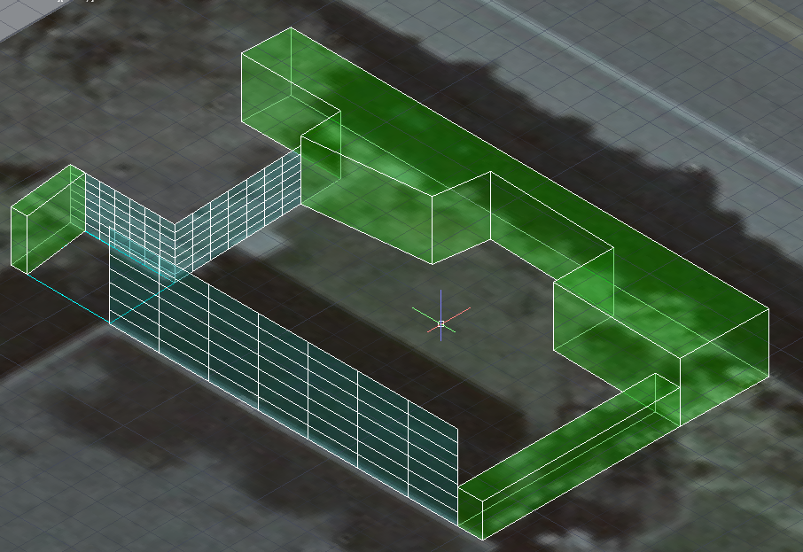
Figure 9: AutoCAD Model - 5098 59A St
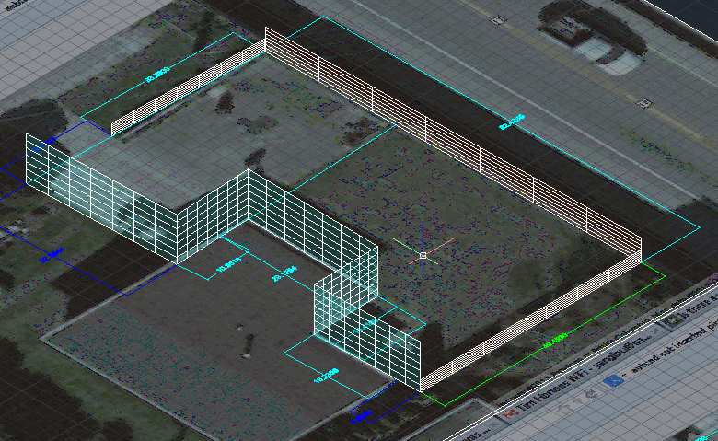
Figure 10: AutoCAD Model - 5076 59A St

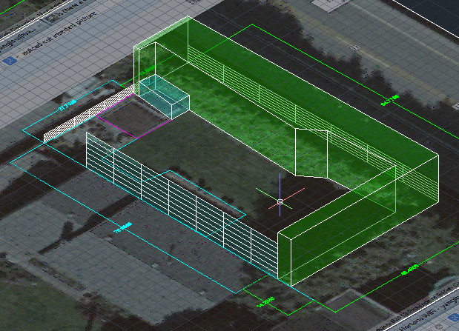
Figure 11 AutoCAD Model - 5052 59A St
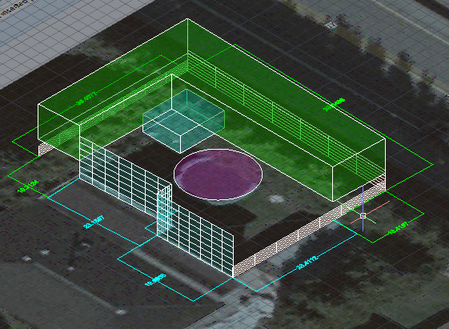
Figure 13: AutoCAD Model - 5040 59A St

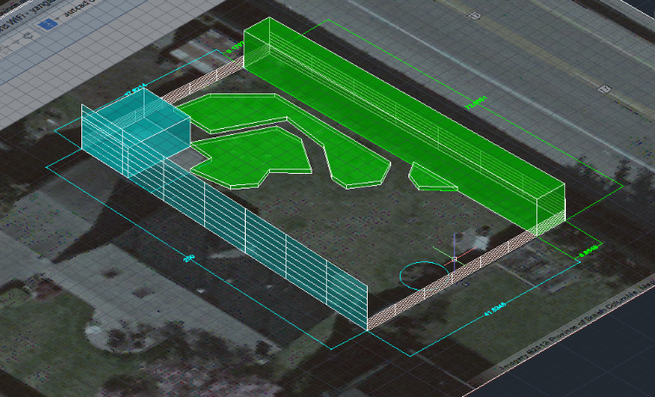
Figure 14: AutoCAD Model - 5018 59A St

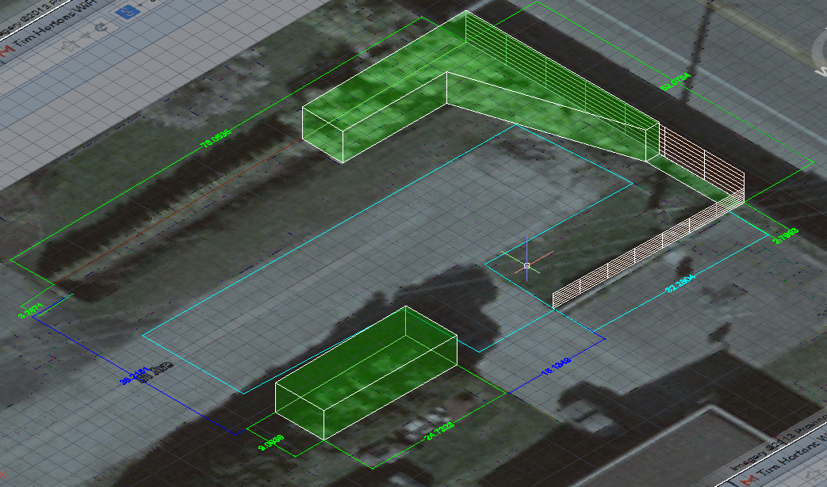
Figure 15: AutoCAD Model - End of 51st

